DIS-AM,C-Taino-Cohoba Snuff Tube

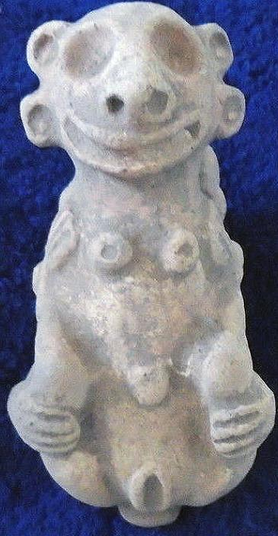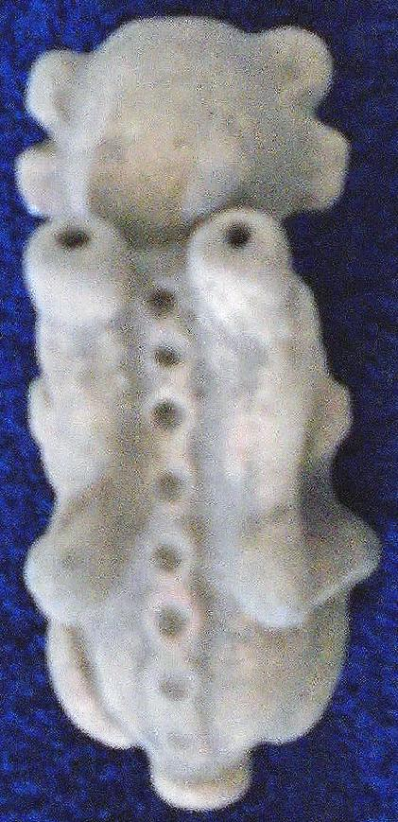

# Order details

## Sales order

Sold by [heratony](http://myworld.ebay.com/heratony) ( [4608](http://feedback.ebay.com/ws/eBayISAPI.dll?ViewFeedback&userid=heratony) )

### Delivery package 1 of 1

Estimated delivery Tuesday, Apr 5, 2016

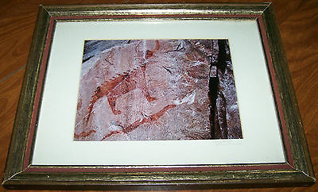

#### [Original Signed Matted Photograph Nature Wildlife PICTOGRAPH LAKE SUPERIOR 11x14](http://www.ebay.com/itm/201468173933)

|  |  |
| --- | --- |
| Item price | $12.00 |
| Quantity | 1 |
| Item number | 201468173933 |
| Shipping service | USPS Parcel Select Ground |

## Sales order

Sold by [guayacanex](http://myworld.ebay.com/guayacanex) ( [500](http://feedback.ebay.com/ws/eBayISAPI.dll?ViewFeedback&userid=guayacanex) )

### Delivery package 1 of 1

Estimated delivery Friday, May 13, 2016 - Wednesday, Jun 1, 2016

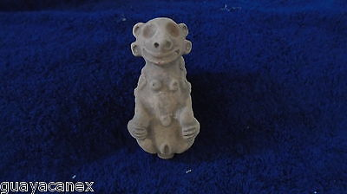

#### [Taino ceremonial Cohoba clay female inhaler or smoking snuffering](http://www.ebay.com/itm/331807922678)

|  |  |
| --- | --- |
| Item price | $199.00 |
| Quantity | 1 |
| Item number | 331807922678 |
| Shipping service | Economy Shipping |

## Shipping address

Ralph J Coffman Jr

149 Atlantic Ave

Swampscott MA 01907-2427

United States

## Order total

|  |  |
| --- | --- |
| Subtotal | $211.00 |
| Shipping | $6.26 |

**Total**

$217.26

Order placed on

Wednesday, Mar 30, 2016

Payment method

PayPal

Payment date

Wednesday, Mar 30, 2016